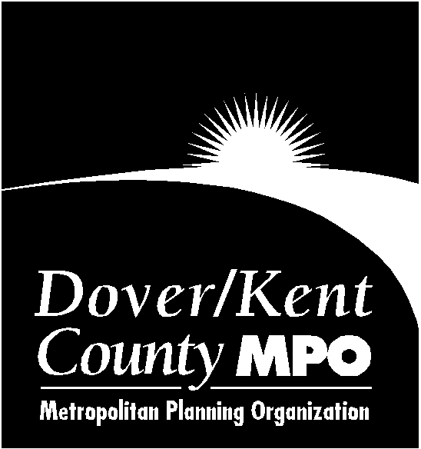

UNIFIED PLANNING WORK PROGRAM

for the

DOVER/KENT COUNTY
METROPOLITAN PLANNING ORGANIZATION

FISCAL YEAR 2021

July 1, 2020 through June 30, 2021

Pending Adoption on March 4, 2020

Prepared at the Direction of the

Dover/Kent County Metropolitan Planning Organization Council

The preparation of this document was financed in part with funds provided by the Federal Government, including the Federal Transit Administration, through the Joint Funding Simplification Program, and the Federal Highway Administration of the United States Department of Transportation.

TABLE OF CONTENTS

PAGE

TABLE OF CONTENTS………………………………………………………………………………………...2

INTRODUCTION………………………………………………………………………………………………..3

MISSION AND GOALS…………………………………………………………………………………………3

PLANNING EMPHASIS AREAS………………………………………………………………………………3

MPO ACTIVITIES………………………………………………………………………………………………5

REGIONAL PRIORITIES………………………………………………………………………………………5

ORGANIZATION
MPO Council……………………………………………………………………………………………………..7
Technical Advisory Committee (TAC) ………………………………………………………………………….7
Public Advisory Committee (PAC)………………………………………………………………………………8
MPO Staff………………………………………………………………………………………………………...8
Funding ………………………………………………………………………………………………………….9
Fiscal Year 2020 Funding Revision ……………………………………………………………………………..10

FY 2021 PROJECTS

21-01 Program Management and Development...................................................................................................12

21-02 Preparation of the Unified Planning Work Program…………………………………………………….15

21-03 Public Outreach………………………………………………………………………………………….16

21-04 Preparation of the Transportation Improvement Program……………………………………………….18

21-05 Data Management………………………………………………………………………………………..19

21-06 Training, Education and Outreach……………………………………………………………………….21

21-07 Update the Long-Range (Metropolitan) Transportation Plan……………………………………………22

21-08 Transportation Planning Projects………………………………………………………………………...23

FUNDING

FY19 Rollover Funds…………………………………………………………………………………………….11
Cost Allocation by Project and Funding Source…………………………………………………………………11
Operating Expenses………………………………………………………………………………………………25

INTRODUCTION

The Fixing America's Surface Transportation Act (FAST), passed in 2015, requires the Metropolitan Planning Organization (MPO), in cooperation with the State and operators of publicly owned transit services, to develop a Unified Planning Work Program (UPWP). The purpose of the UPWP is to present the planning priorities facing the metropolitan planning area and describe all metropolitan transportation and transportation-related air quality planning activities anticipated therein during the next fiscal year, regardless of funding sources or agencies conducting activities. The discussion should be provided in sufficient detail to indicate who will perform the work, the schedule for completing it, and the products that will be produced.

Every effort has been made to include all of the member agencies of the Dover/Kent County MPO (D/KC MPO) as well as representatives of the Technical and Public Advisory Committees in the compilation of this work program.

MISSION

The MPO serves as a cooperative regional forum for the development of transportation system plans and programs and for the resolution of transportation planning-related issues in the MPO's designated region. In January 2020, the D/KC MPO planning area boundary was clarified as being the “whole” of Kent County, Delaware. Two Kent County municipalities which have annexed properties into neighboring counties, will require additional coordination with adjacent transportation planning agencies. The Town of Smyrna, which has annexed properties in New Castle County, Delaware will have to coordinate with the Wilmington Area Planning Council (WILMAPCO) and the City of Milford annexed properties in Sussex County, will have to coordinate with DelDOT. The D/KC MPO's mission is to ensure the implementation of the most efficient multi-modal transportation plans and programs which meet the requirements of the Federal Clean Air Act Amendments (CAAA) of 1990 and FAST.

The D/KC MPO uses the Comprehensive, Continuing and Cooperative (3-C) metropolitan transportation system planning process. This process is also utilized by the member agencies of the MPO Council.

STRATEGIC GOALS

The D/KC MPO has established three goals to support the mission:

- Coordinate transportation planning and programming in the region

- Foster cooperative relationships between State, Municipal and County governments

- Improve the public’s understanding of the metropolitan transportation planning process and its relationship to other planning activities in the D/KC MPO region

To accomplish these goals, the D/KC MPO’s activities are divided into three categories: administration of the metropolitan planning process; public education and outreach; and transportation planning.

PLANNING EMPHASIS AREAS

The FAST Act has continued to focus on transportation planning as was outlined in preceding federal transportation legislation. In accordance with that focus, the Federal Highway Administration (FHWA) and the Federal Transit Administration (FTA) released their Planning Emphasis Areas (PEA's) in March 2015. PEA's are planning topical areas that the Federal agencies wish to place emphasis on as the MPOs develop their planning work programs. The current PEA's are described below.

Performance-Based Management Approach

The Federal transportation agencies, as well as the Delaware Department of Transportation (DelDOT), has recognized the importance of transitioning to performance-based planning and programming. The UPWP should promote development and implementation of a performance management approach to transportation planning and programming that supports the achievement of transportation system performance outcomes. To better understand the D/KC MPO approach to performance-based planning, some background history is required.

The Moving Ahead for Progress in the 21st Century Act (MAP-21) directed MPOs to develop Long Range Transportation Plans (LRTP) and Transportation Improvement Programs (TIP) through a performance-driven and outcome-based approach to planning. It requires states, MPOs, and operators of public transportation to establish targets for performance measures in key performance areas which address national goals for Federal Highway Administration (FHWA) and Federal Transit Administration (FTA), and coordinate with one another when setting these targets. There are seven FHWA national goals (safety; infrastructure (pavement and bridge) condition; congestion reduction; system reliability; freight movement and economic vitality; environmental sustainability; and reduced project delivery delays) and two FTA national goals (safety; and infrastructure condition (state of good repair-transit asset management). Performance-based planning applies data to inform decisions aimed at helping achieve desired outcomes for the region's multimodal transportation systems as documented in three main documents. First, our LRTP (2017 Metropolitan Transportation Plan (MTP)) is an investment plan covering 20 years; second, our TIP which is a four-year plan for funding capital infrastructure projects; and third is the UPWP, produced annually to support conceptual plans and research.

In many ways the D/KC MPO is already applying performance-based principles when making investment decisions as part of the MTP, TIP and UPWP development process. Nonetheless, the United States Department of Transportation (DOT) established seven measure areas categorized in three performance measures (PMs) the D/KC MPO was responsible for establishing targets for in FY18 and FY19: Safety Measures (PM1); Pavement and Bridge Condition (PM2); and the Performance of the NHS (National Highway System), Freight and CMAQ (Congestion Mitigation and Air Quality) (PM3). The D/KC MPO decided to adopt the Delaware Department of Transportation (DelDOT) PM targets and adopted DelDOT’s PM1 standards on March 7, 2018, as well as targets for PM2 and PM3 measures on November 14, 2018.

In addition to the three PMs, DOT established three related rules categorized in two performance areas (Asset Management and Planning). As such, D/KC MPO Council adopted the Delaware Transit Corporation’s (DART) Transit Asset management Plan (TAMP) on March 6, 2019.

The recommendation for the D/KC MPO Council to adopt DelDOT’s PM1, PM2, and PM3 standards and DART’s TAMP was made after DelDOT and Federal Highways Administration representative consultation and given the size of Delaware, the D/KC MPO decided to utilize the targets established by DelDOT and DART as offered in Federal guidance. The D/KC MPO will be required to include the Performance Measures targets in all future primary documents we produce. The D/KC MPO will have the opportunity to fine tune the PM1, PM2, PM3 targets, and TAMP beginning in CY2020.

Models of Regional Planning Cooperation

The UPWP should promote cooperation and coordination across MPO and State boundaries where appropriate to ensure a regional approach to transportation planning. This is particularly important where more than one MPO or State serves an urbanized area or adjacent urbanized areas. This cooperation could occur through the metropolitan planning agreements that identify how the planning process and products will be coordinated, through the development of joint planning products, and/or by other locally determined means. Coordination across MPO and State boundaries includes the coordination of transportation plans and programs, corridor studies, and projects across adjacent MPO and State boundaries. It also includes collaboration among DOTs, MPOs and the Delaware Transit Corporation (DTC) on activities such as data collection, data storage and analysis, analytical tools, and performance-based planning. The D/KC MPO has a long history of coordination with DelDOT, DTC, and the State's other MPOs (the Wilmington Area Planning Council and the Salisbury-Wicomico County MPO) and will continue that cooperation in FY 2020 through the conduct of planning studies, information sharing, and technical assistance.

Ladders of Opportunity

As part of the transportation planning process, the MPO should identify transportation connectivity gaps in access to essential services such as housing, employment, health care, education, and recreation. This emphasis area could include identification of performance measures and analytical methods to measure the transportation system's connectivity to essential services and the use of this information to identify gaps in connectivity that precludes access of the public, including traditionally underserved populations, to essential services. It could also involve the identification of solutions to address those gaps. The D/KC MPO has worked with local groups in the recent past to identify gaps within the urbanized area, particularly as it relates to access to healthy foods and recreational opportunities. In FY 2018 for example, the D/KC MPO worked with WILMAPCO, the Office of State Planning Coordination, and several state and private health-related organizations to contribute to an article for a volume of the Delaware Journal for Public Health entitled “Planning and Public Health”. In FY 2021, the D/KC MPO will continue coordinating with Kent County municipalities and local interest groups to identify these gaps and address potential solutions.

Vision Zero

Vision Zero is a Federal Highways Administration (FHWA) initiative that strives to eliminate all traffic fatalities and severe injuries, while increasing safe, healthy, equitable mobility for all. The D/KC MPO will be involved with the State’s established safety committee to promote the Vision Zero and Toward Zero Deaths initiatives. Primarily the D/KC MPO’s support will be in Public Outreach - creating content for social media, sharing information on the D/KC MPO website, and helping to educate and involve the public.

MPO ACTIVITIES

Administration of the Metropolitan Planning Process

Projects 21-01, 21-02, 21-04, 21-05, and 21-07 represent the assignments that must be completed to satisfy the requirements of Federal regulations and ensure that State, County and municipal governments engage in a cooperative process to determine the priority of the region’s transportation needs. These projects support the D/KC MPO’s efforts to reach out to all member governments as well as the public to develop a consensus of agreement for transportation plans and programs that support the region’s land use and transportation goals, and to facilitate the flow of information relating to transportation and land use between the member governments and the public.

Public Education and Outreach

Projects 21-03 and some of 21-06 represent the outreach that are required as a component of the metropolitan planning process. The D/KC MPO believes it can improve the ability of the public, elected officials, citizen planners and D/KC MPO members to participate in all planning processes by implementing a public education program. Consequently, the work program also includes activities to help communicate how the planning process works as well as current trends and best planning practices.

Support Regional Planning

Project 21-08 is intended to support regional transportation planning either financially or through staff participation. This project brings together the transportation and land-use planning processes. Through the TAC, agencies in the D/KC MPO region involved in planning activities share information about their projects to ensure efforts are not being duplicated. Upon request, member governments provide the D/KC MPO with a list of transportation planning projects which support the goals listed in the Metropolitan Transportation Plan and overall regional transportation initiatives and these studies will be selected based on current D/KC MPO Transportation Planning Project/Study policy.

REGIONAL PRIORITIES

The D/KC MPO’s 2017 Metropolitan Transportation Plan (MTP), which has a 20-year planning horizon, assesses the region's short-term improvement needs, projects future needs, and identifies goals and objectives to meet those needs. The MTP must be financially reasonable and result in a positive impact on the region's air quality. The planning process is coordinated with DelDOT's Statewide planning process, Kent County's Comprehensive Plan, and the City of Dover's Comprehensive Plan. Efforts are also made to coordinate planning efforts with the other 19 municipalities in the D/KC MPO region.

The 2017 MTP provides a framework to guide all future transportation planning and programming activities. The following goals are identified for Kent County:

- Move People Safely and Efficiently

- Strengthen Communities

- Promote Economic Development

A hierarchy of fundamental objectives supports these goals and further guides transportation planning and programming decisions:

- Maintain existing infrastructure

- Shorten project delivery

- Improve accessibility for all users

- Maximize transit ridership

- Minimize average delay times

- Enhance human health

- Preserve Natural Resources/Enhance community resources

- Maintain effective transportation networks

- Ensure economic development is considered in project prioritization

- Evaluate the transportation needs of designated and proposed economic growth areas

This UPWP includes projects that support these goals and strategies, strive to keep Kent County a great place to live and work, keep Dover a strong metropolitan center, and to support Milford, Smyrna, and other towns within the growth corridor.

During FY 2020-2021, the D/KC MPO will be updating its 2017 MTP. The 2020 MTP, titled “Innovation 2045,” will identify transportation needs, provide strategies to address those needs, guide transportation investment, and provide measurable goals and performance measures for Kent County’s transportation system over the next 25 years. Innovation 2045 will also help shape local, regional, and State strategies for addressing economic growth, safety, congestion, air quality, and public mobility. Through a process of intergovernmental cooperation and coordination at the State, federal and local level, as well as citizen involvement, the primary goal of our Innovation 2045 plan is to bring all affected parties to the table in order to address the unique transportation needs of each locality and region, while providing a forum to address the overall transportation infrastructure growth and development for Kent County Delaware. Lastly, Innovation 2045 will identify transportation projects in Kent County which are eligible for Federal funding. Innovations 2045 is currently scheduled to be completed by January 2021.
ORGANIZATION

- MPO COUNCIL

The policy making body of the D/KC MPO is its Council, which consists of six voting members representing each of the following:

1. The Governor of the State of Delaware
2. Mayor of the City of Dover
3. President of the Levy Court of Kent County
4. The Secretary of the Delaware Department of Transportation
5. The Director of the Delaware Transit Corporation
6. Representative of Kent County Municipalities

The Federal Highway Administration (FHWA) and the Federal Transit Administration (FTA) sit on the MPO Council as non-voting members.

The current members/representatives to the Dover/Kent MPO Council are listed below:

1. Robin R. Christiansen, Mayor, City of Dover
2. Michael Petit de Mange, for Brooks Banta, President, Kent County Levy Court
3. Terry Pepper, for John Carney, Governor of Delaware
4. Drew Boyce, for Jennifer Cohan, Secretary, Delaware Department of Transportation
5. John Sisson, Executive Director, Delaware Transit Corporation
6. Anthony Moyer, Mayor, City of Harrington, Representative of Kent County Municipalities

- TECHNICAL ADVISORY COMMITTEE (TAC)

The TAC consists of technical staff from all D/KC MPO member agencies. It performs analyses and makes recommendations concerning transportation and land use issues to the Council for its approval. The actual technical work is performed jointly by the D/KC MPO staff and the TAC member-organizations. The TAC elects its own chairperson and vice-chairperson annually from among its members to serve for a one-year period. The current membership of the TAC:

- Marvina Cephas, Delaware Department of Natural Resources and Environmental Control
- David Edgell, Delaware Office of Statewide Planning Coordination
- David Hugg, Director, City of Dover Department of Planning and Inspections
- Nathan Attard, Delaware Department of Transportation
- Milton Melendez, Delaware Department of Agriculture
- Patty Cannon, Delaware Division of Small Business*
- Kris Connelly, Kent County Planning Department
- Catherine Smith, Delaware Transit Corporation
- Sharon Duca, City of Dover Public Works
- Tim Riley, Kent Conservation District
- Matthew Jordan, Dover Air Force Base
- Aaron Chaffinch, Town of Camden
- Jeremy Rothwell, Town of Smyrna
- Rob Pierce, City of Milford

*Formerly the Delaware Economic Development Office, or DEDO.

Delmarva Central Railroad (formerly Norfolk Southern), Delaware Motor Transport Association, the Federal Highway Administration and the Federal Transit Administration are non-voting members of the TAC.

- PUBLIC ADVISORY COMMITTEE (PAC)

The Public Advisory Committee (PAC) is a group of local citizens appointed by the D/KC MPO Council members. Each member of the PAC serves for a period of two years. The PAC elects its own chairperson annually from among its members for a term of one year. They represent a variety of business, civic, and interested citizen groups from Kent County. The PAC provides advice and comments on current and future issues concerning the citizens' perspectives on the impact of the transportation plans and programs in the D/KC MPO area. The PAC also provides a forum for the public to express their concerns about all transportation and land-use related activities.

City of Dover Appointees
Jonathan Contant
Karen McGloughlin
(There is one vacant position)
Albert W. Holmes – alternate-at-large

State Appointees (DelDOT, DTC, Governor’s Office)
Dr. Phyllis Collins
Shane Breakie
Michael Gumrot
Tracey M. Miller

Kent County Levy Court Appointees
Dr. Carolyn Cohee
Jayce Lesniewski
Bruce Snow
Jesse Spampinato
Chris Asay
(There is one vacant position)

Municipal Appointee (City of Harrington)
(Currently vacant)

D/KC MPO STAFF

The D/KC MPO staff performs the day-to-day operations of the agency, with technical expertise in administration, planning and public affairs. The staff, in conjunction with the D/KC MPO's member agencies, collects, analyzes, and evaluates demographic, land use, and transportation-related data to understand the transportation system requirements of the region. The staff also prepares materials for use at TAC, PAC, and Council meetings. The professional staff members participate in all D/KC MPO meetings and provide technical support. In addition, they represent the agency at meetings of importance to planning activities within the region. In Fiscal Year 2021 the following staff positions are authorized:

Executive Director: D. Reed Macmillan
Executive Assistant: Catherine Samardza
Principal Planner: James Galvin
Outreach Manager: Helen Wiles
Planner II: (currently vacant)
GIS/Mapping (part time): Mike Ward
Administrative Assistant (part time): Darien Sawicki
FUNDING

This UPWP is funded predominantly by FHWA Metropolitan Planning (PL) funds, as described in Title 23 of the United States Code (Section 104) and FTA Section 5303 funds. All federal transportation funds are administered by DelDOT and made available to the D/KC MPO on a reimbursement basis. These funds cannot constitute more than 80 percent of the total D/KC MPO work program; therefore State, County and local governments must provide a 20 percent match. In FY21, this match will be comprised of cash provided by DelDOT (to include 20% transportation study contract costs for two transportation studies). DelDOT is covering all of our 20% Federal Funding match and therefore, there is no need for additional local cash contribution or in-kind match hours for FY21. The following information however, describes how in-kind match hours will be used.

As a small agency it is difficult for the D/KC MPO staff to complete all the tasks needed to accomplish the UPWP. Consequently, member agencies and governments may contribute services. The following table shows the agencies/jurisdictions involved in providing various kinds of services.

State Agencies | Local/County Governments
Department of Natural Resources and Environmental Control | Dover
Office of State Planning Coordination | Kent County
Department of Homeland Security | Milford
Department of Agriculture | Smyrna
Delaware Division of Small Business | Camden
Kent Conservation District | Harrington

Tasks that these agencies and local governments include, but are not limited to:

- Gathering, analyzing and evaluating and sharing demographic and land use data
- Serving on committees and task forces
- Reviewing studies, reports and agreements
- Preparing presentations and materials for meetings
- Making presentations
- Distributing materials
- Facilitating communication with elected and other officials
- Supporting the D/KC MPO website
- Advertising D/KC MPO events
FISCAL YEAR 2021 FUNDING

The D/KC MPO Fiscal Year runs from July 1 of the current calendar year to June 30 of the next calendar year. The proposed FY21 UPWP budget includes the FY21 allotment ($642,567.50) and available roll over funding from FY19 ($20,067.96) at a total of $662,635.46.

Cost Allocation by Project and Funding Source

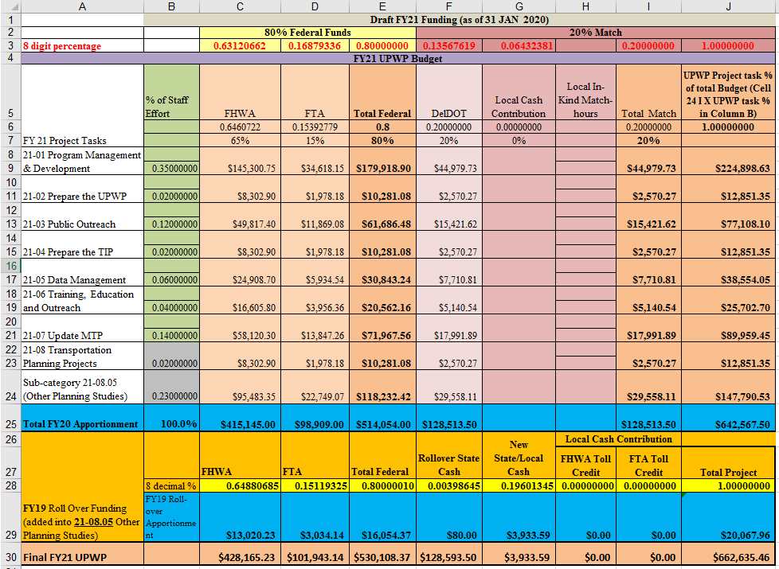

NOTE: As part of the 20% Match, the DelDOT contribution (column F) is 20% or $128,513.50.

NOTE: UPWP 21-08.05 (Other Planning Studies) is documented in this chart to show where the FY19 (row #29) roll over funding will be included. Other sub-categories in the FY21 UPWP are described in each of the eight UPWP Projects within this document.

NOTE: The Projected FY21 Transportation Study amount is $167,858.49 and consists of $147,790.53 (FY21 Operational Funding) and $20,067.96 (FY19 Rollover funding).

Local Funding. As seen in the chart above, 80% funding for the D/KC MPO comes from the Federal Government (FHWA/FTA), 20% from DelDOT, and 0% from local D/KC MPO partners.

Roll Over Funding. Any unused D/KC MPO funding from the previous fiscal years are consolidated and "rolled over" into the current fiscal year and as such, these funds must be applied to the UPWP through an amendment. For example, the $20,067.96 in FY19 roll over into FY21 funding program will be used to fund transportation planning projects/studies as applicable in UPWP task #21-08.05.

The FY19 roll over funds and FY21 operating funds for UPWP Task #21-08.05 will be used to fund selected transportation planning projects identified in the chart below. Currently, DelDOT projects scoring #1 and #2 are slated to be funded but at a 24% reduced scope since the current total for the two projects is $221,675.70 and we only have $167,858.49 for FY21 transportation study funds.

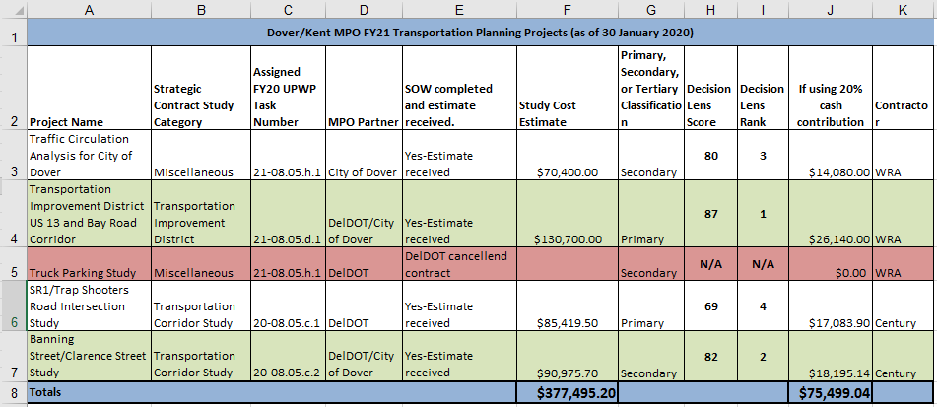

Project 21-01 Program Management & Development

As part of this task, the D/KC MPO will annually implement the Unified Planning Work Program, negotiate project funding, prepare and submit required applications and contract documents, and monitor program progress. In addition, the D/KC MPO will provide input to the Council and its committees and receive output (products) from all projects. This task also covers program administration and interagency coordination.

21-01.01 Manage/Maintain the MPO Office: This project includes all activities that must be performed to keep the D/KC MPO office operational including:

  - Manage the daily operations of the D/KC MPO office
  - Purchase and maintain equipment and facilities
  - Investigate strategies to improving the efficiency of office operations
  - Administer all contracts between the D/KC MPO and other entities
  - Process accounts payable and receivable
  - Prepare monthly reimbursement requests and all progress reports
  - Recruit/retain/evaluate personnel and maintain personnel records
  - Monitor the progress of the Unified Planning Work Program
  - Attend training, conferences and seminars to ensure that D/KC MPO staff involved in these activities are knowledgeable about the federal and state regulations that the MPO must follow

Completion Date: Ongoing

21-01.02 Support the MPO Council and Committees: The D/KC MPO staff provides technical support to the MPO Council and committees so that they can make informed decisions about the region’s transportation priorities. The staff works to ensure that these bodies function effectively, that they receive meeting materials in a timely fashion to help them make informed decisions and that their regular meeting schedule is maintained. Activities to support the D/KC MPO Council and committees include:

- Coordinate and schedule all business to be transacted by the D/KC MPO Council, the TAC, and the PAC
- Prepare meeting notices, agendas and minutes
- Compile and synthesize technical information for presentation to the D/KC MPO Council and committees
- Coordinate planning discussions and activities between different levels of government in the region
- Provide D/KC MPO status reports to D/KC MPO Council Chair and members when required
- Continuously reach out to state, county, and local elected officials to ascertain the needs of their constituents and share that information with D/KC MPO members
- Expand the consultation process to include all interested parties identified in the FAST Act
- Coordinate discussions dealing with air quality and its impact on the transportation program, particularly in regard to conformity analyses and determinations

Completion Date: Ongoing

21-01.03: Continue the 3C Planning Process: The D/KC MPO staff provides support and facilitates an open Comprehensive, Cooperative, and Continuing (3C) transportation planning and programming process at all levels of government in conformance with applicable federal and state requirements and guidelines as described in memorandum of agreements for the allocation and administration of planning funds. Activities to support the 3C process include:

  - Meet with community and business leaders to ascertain their transportation concerns
  - Participate in planning activities and discussions concerning freight movement through the region
  - Attend meetings of local, regional and national associations/organizations that are pertinent to the
business of the D/KC MPO, including but not limited to:
  - Central Delaware Chamber of Commerce
  - State Freight Plan
  - Air Quality Interagency Consultation Process
  - Hazard Elimination Program Committee
  - Working groups/advisory committees for transportation projects in the D/KC MPO region
  - Dover Safety Advisory and Transportation Committee
  - Pedestrian Council
  - DE Chapter of the American Planning Association

  - Provide coordination with Kent County communities, DelDOT, DART, and private transportation
providers
  - Review technical literature on transportation planning procedures
  - Review federal and state transportation regulations pursuant to include but not limited to the Intermodal
Surface Transportation Efficiency Act (1991); National Highway System Designation Act (1995);
Transportation Equity Act for the 21st Century (1998); Safe, Accountable, Flexible, Efficient Transporta- tion Equity Act: A Legacy for Users (2005); Moving Ahead for Progress in the 21st Century Act (2012); and Fixing America's Surface Transportation Act (2015)

Completion Date: Ongoing

21-01.04: Program Support and Administration: The D/KC MPO 2021 program support and administration activities include the financial and personnel management of the transportation planning program, public information and assistance, the development of the 2021 D/KC MPO Unified Planning Work Program (UPWP), the monthly invoices and reports to the FHWA, FTA, and DelDOT, transportation planning staff education, and monthly procurement activities supporting tasks within the 2021 UPWP. Activities to support this task include:

  - Prepare monthly invoices regarding staff time and supplies procured to implement this UPWP task.
  - Monitor direct and indirect cost for compliance with the D/KC MPO Indirect Cost Allocation Plan (ICAP) by
identifying the UPWP task which benefits directly from the expense (i.e. staff time, supplies, facility
costs, etc.).
  - Coordinate with assigned accountant or auditor to ensure fiscal policies and requirements are properly
executed and managed.
  - Ensure D/KC MPO program personnel requirements are properly implemented per approved personnel
policies such as staff time recordation, staff counseling, and staff performance reviews.

Completion Date: Ongoing

21-01.05: FOIA Compliance: Under Delaware's Freedom of Information Act, 29 Del. C. §§ 10001-10006 ("FOIA"), a FOIA request or petition, along with any information contained therein or any documents attached thereto, submitted to any "public body" subject to FOIA, including, without limitation, any board, bureau, commission, department, agency or committee of the State, may itself be deemed a "public record" subject to disclosure under FOIA. Activities which support this task include:

  - Prepare and publish monthly PAC, TAC, and D/KC MPO Council Agendas
  - Record retention activities such as scanning documents into electronic media for ease of retrieval
  - Ensure applicable meetings are recorded and a system in place to retrieve meeting recordings and written
meeting minutes.
  - Manage D/KC MPO program documents in a file system that is in compliance with FOIA requirements

Completion Date: Ongoing.

Products:

- Successful implementation of the Unified Planning Work Program
- Progress reports, Annual Report, and other transportation-related documents and information
- Memorandum and reports as needed
- Properly executed contracts, agreements, and grant applications
- Monthly invoices and progress reports
- Updates and amendments to certification documents as required
- An accurate public record of all D/KC MPO Council, TAC, and PAC meetings

Responsible Agencies: D/KC MPO staff and member agencies – DelDOT, DTC, City of Dover, Kent County, DNREC, Delaware Division of Small Business, State Planning, City of Milford, Town of Smyrna, Town of Camden, City of Harrington

Staff Support: Reed Macmillan, Executive Director
Catherine Samardza, Executive Assistant
Darien Sawicki, Administrative Assistant

Project 21-02 Unified Planning Work Program (UPWP)

21-02.01 Prepare the FY 2022 UPWP: The MPO staff works with the member governments to develop the next unified planning work program which describes the transportation-related planning activities anticipated in the Dover metropolitan area during the next one- to two- year period including all planning work to be performed regardless of funding source or the agencies conducting the activities, which meets the requirements of 23 CFR Part 420, sub-part A. The UPWP also indicates who will perform the work, the schedule for completing it, and the products that will be produced. This task involves the following activities:

  - Identify planning priorities with Council and Committees
  - Identify funding sources and amounts
  - Request information about projects being completed by other agencies
  - Draft a proposed program and solicit public comments
  - Review and adoption by D/KC MPO Council and committees
  - Prepare and execute the funding agreement with DelDOT

Completion Date: March 2021

21-02.02 Modify the FY 2021 UPWP: During the course of the year, changes may need to be made to the existing UPWP as a result of new or changed planning priorities identified through interagency consultation or because of budget issues. Additional activities associated with the UPWP include:

  - Prepare monthly PAC, TAC, and D/KC MPO Council Agendas
  - Identify modifications that need to be made to the UPWP
  - Estimate costs and justifications
  - Prepare UPWP amendments and present to the D/KC MPO Council and committees
  - Prepare and execute amended funding agreements
  - Monitor work schedule and budget for FY2020
  - Ensure estimated staff hours for each UPWP task are being monitored and corrected when required

Completion Date: As needed

Products:

- An annual UPWP which describes all planning activities to be performed in the D/KC MPO region.

Responsible Agencies: D/KC MPO staff and member agencies – DelDOT, DTC, City of Dover, Kent County, DNREC, Delaware Division of Small Business, State Planning, City of Milford, Town of Smyrna, City of Harrington

Staff Support: Reed Macmillan, Executive Director

Project 21-03 Public Outreach

One of the key components of the metropolitan planning process is a public outreach program that invites anyone with an interest in the transportation system to become involved. That outreach takes many forms, includes many audiences and is monitored by the PAC. Another object is to provide the public with complete information, timely notice, and opportunities for continuing involvement in the 3C process and ensure that all segments of the population are able to fully participate. The activities in this project support the PAC and public outreach program.

21-03.01 Conduct Outreach to Support Recurring D/KC MPO Activities: On a regular basis, the D/KC MPO advertises its meetings, responds to inquiries, coordinates public outreach efforts with its member governments and monitors its public outreach process. Activities carried out under this project include:

  - Prepare media releases and announcements advertising D/KC MPO meetings and special events
  - Maintain media relations with private, local, state, and federal public relations entities for coordinated
media releases regarding D/KC MPO activities
  - Ensure D/KC MPO Program Management and Development, UPWP, Public Outreach, TIP, Data Management,
Training, and Transportation initiatives (when applicable) are available in an appropriate form for public
information distribution (i.e. e-newsletter, articles in papers, flyers, etc.)
  - Retain a record of items distributed and information disseminated by publications/media outlets
  - Arrange logistics for public meetings held away from the D/KC MPO office
  - Investigate opportunities for coordinating the D/KC MPO's public participation process with member
governments’ and other MPOs’ public participation processes
  - Participate in public fairs or events where information about D/KC MPO plans, programs and activities can be
disseminated
  - With the members of the PAC, review all lists of stakeholders, including identifying low income and
minority citizens that may not have easy access to the metropolitan planning process, and update accordingly
  - Coordinate outreach activities with other groups, such as the Air Quality Partnership

Completion Date: Ongoing

21-03.02 Prepare the D/KC MPO Newsletter, Journeys: The agency's newsletter is scheduled to be published monthly. Activities to publish the newsletter include:

  - Compile information, write articles, select photos and/or artwork, and develop layout
  - Solicit articles to include from member governments or associated agencies
  - Distribute the newsletter to all interested parties
  - Develop and distribute an electronic version of the newsletter

Completion Date: Twelve (12) times per calendar year

21-03.03 Maintain D/KC MPO Social Media accounts and website: The D/KC MPO continually strives to keep information about MPO activities updated through social media venues that include but are not limited to Facebook, Twitter, Instagram and its website. Activities to increase the D/KC MPO’s electronic and social media outreach include:

- Work with the Delaware Government Information Center (DE GIC) office to keep the site organization and structure current
- Implement technical changes to the website
- Post information on the website about the D/KC MPO’s activities
- Maintain information on Twitter, Facebook, and other social media venues

Completion Date: Ongoing

21-03.04 Conduct the Annual PAC Workshop: Organize and hold a workshop to provide orientation to the metropolitan planning process for new members, engage all PAC members in discussing their roles in the planning process and creating ideas for outreach activities. Activities to accomplish this workshop include:

- Arrange a time and place to hold the workshop
- Schedule speakers, if appropriate
- Conduct the workshop

Completion Date: June 2021

Responsible Agencies: D/KC MPO staff and appointees from designated agencies.

Staff Support: Helen Wiles, Public Outreach Manager
Darien Sawicki, Administrative Assistant

Project 21-04 Transportation Improvement Program

The D/KC MPO is charged with compiling the region's Transportation Improvement Program (TIP), which identifies those projects for which federal funding may be requested over a four-year period. DelDOT selects the projects to be included in the TIPs based on the priorities developed through the metropolitan planning process. The TIP must contain a financial plan that enumerates the funding sources for the projects in the TIP and proves that the TIP is fiscally constrained. An air quality conformity determination must be made to demonstrate that the transportation system that is created as a result of the projects in the TIP will not worsen the region’s air quality. Finally, the public must have an opportunity to review and comment on the TIP projects before they are approved by the D/KC MPO.

21-04.01 Develop the FY 2021-2024 TIP: During FY 2021, the D/KC MPO will prepare the FY 2021-2024 TIP. Activities to complete this project include:

- Solicit project submittals from D/KC MPO members
- Prioritize projects submitted to the TIP
- Submit a list of candidate projects for the FY 2021-2024 TIP to DelDOT for evaluation and
funding consideration
- Solicit public comments on the proposed TIP in conjunction with DelDOT and the COT
- Conduct virtual tour of proposed TIP project locations
- Determine if a new air quality conformity analysis is needed
- Draft support documents for project list including financial constraint, annual listing of projects, and air
quality conformity determination
- Subject the draft document to a 30-day public comment period
- Approve the FY 2021-2024 TIP and distribute and post on the D/KC MPO website

Completion Date: May 2021

21-04.02 Amend the FY 2020-2023 TIP: During FY 2021, the D/KC MPO may amend the current year TIP to reflect significant changes in funding or project scope. Activities related to this project include:

- Review the adopted Bond Bill and other proposed changes to the TIP with DelDOT and determine if an
amendment is needed
- Prepare a draft amendment document, including financial constraint, annual listing of projects, and air
quality conformity determination
- Subject the draft document to a 30-day public comment period
- Approve amendments to the TIP

Completion Date: As needed

Products:

- A published TIP document that meets federal requirements
- A published TIP which is incorporated into the STIP (DelDOT)

Responsible Agencies: D/KC MPO staff and member agencies – DelDOT, DTC, City of Dover, Kent County, DNREC, Delaware Division of Small Business, State Planning, City of Milford, Town of Smyrna, Town of Camden, City of Harrington

Staff Support: James Galvin, Principal Planner

Project 21-05 Data Management

In order for the D/KC MPO Council and committees to make informed decisions, they need to have access to data about the transportation system and the people who use it. The D/KC MPO maintains a GIS system for organizing and presenting data that has been gleaned from other sources and occasionally helps to fund the collection and analysis of new data. The maps and displays developed through GIS are also an important element of the public participation process.

21-05.01 Operate and Maintain the Geographic Information System: This project will maintain and update the D/KC MPO’s existing GIS by improving communication and data sharing with other agencies and adding new data as it becomes available from other reliable sources. The activities to complete this project include:

- Work with member governments to identify sources for data that the D/KC MPO will need during the year
and the process for accessing the data - Continuous
- Update GIS data from federal, state and local sources - Continuous
- Refine/maintain a database that identifies locations of minority, low income and other under-served
populations that may be adversely impacted by the construction of or lack of transportation improvement
projects - Continuous
- Integrate survey data from the Center for Applied Demographic Research - As available
- Partner with D/KC MPO member agencies and other organizations to build data sets and collect data. As
needed
- Integrate visualization techniques into the GIS - Continuous
- Create maps and displays for D/KC MPO meetings and projects as requested
- Participate in regional, statewide and national committees and organizations pertinent to operating and
maintaining a top-notch GIS system for the D/KC MPO including:
- Population Consortium
- Delaware Geographic Data Committee

Completion Date: Ongoing

21-05.02 Support the Data and Demographics Working Group: In FY 2011, the D/KC MPO created the Data and Demographics subcommittee for the purpose of developing small area population and employment projections and revising traffic analysis zone (TAZ) boundaries. It was later changed to a Working Group. The Working Group meets to evaluate county-level projections developed by the Population Consortium and disaggregate them to the TAZ level and to discuss other data of concern to the D/KC MPO.

In addition, the D/KC MPO continually re-examines and redefines analysis zone boundaries based on changes in demographics and the highway system. This project will continue that process and evaluate TAZ boundaries in relation to the 2010 Census as well as evaluating 2020 Census results, as needed.

Completion Date: As needed

21-05.03 Performance Measures Data: D/KC MPO staff will work with DelDOT to establish performance measures for UPWP tasks. Performance management is part of the Federal-aid highway program and provides a means to the most efficient investment of Federal transportation funds by refocusing on national transportation goals, increasing the accountability and transparency of the Federal-aid highway program, and improving project decision-making. The D/KC MPO will draft an agreement regarding performance measure data sharing and coordination with the State. Activities to complete this project include:

- Setting of D/KC MPO targets. Within 180 days of States or providers of public transportation setting
performance targets, requires MPOs to set performance targets in relation to the performance measures
(where applicable). To ensure consistency, each MPO must, to the maximum extent practicable, coordinate
with the relevant State and public transportation providers when setting performance targets. [§1201; 23
USC 134(h)(2)].

- Plans requiring targets. Requires the following plans to include State targets (and/or D/KC MPO targets, as
appropriate):
  - Metropolitan transportation plans [§1201; 23 USC 134(i)(2)(B)]
  - Metropolitan Transportation Improvement Program (TIP) [§1201; 23 USC 134(j)(2)(D)]
  - Statewide Transportation Improvement Program (STIP) [§1202; 23 USC 135(g)(4)]
  - State asset management plans under the National Highway Performance Program (NHPP) [§1106; 23 USC 119(e)]
  - State performance plans under the Congestion Mitigation and Air Quality Improvement program [§1113(b)(6); 23 USC 149(l)]
- Ensure the D/KC MPO targets are included in statewide transportation plans [§1202; 23 USC 135(f)(7)]

Completion Date: Ongoing

Products:

1) An updated GIS database that includes all available Census and survey data
2) Maps and other visual materials in support of D/KC MPO reports and presentations
3) Traffic analysis zones that cover the most useful geographic areas for aggregating data
4) Better data upon which decisions can be made
5) TAZ-level population and employment projections that will be used to update the MTP
6) Performance measures approved by DelDOT

Responsible Agencies: D/KC MPO staff and member agencies – DelDOT, DTC, City of Dover, Kent County, DNREC, Delaware Division of Small Business, City of Milford, Town of Smyrna, Town of Camden, City of Harrington

Staff Support: James Galvin, Principal Planning
Mike Ward, GIS/Mapping

Project 21-06 Training, Education and Outreach

The metropolitan planning process brings together a variety of people and organizations involved in shaping the built environment. The consequences of their decisions are far-reaching and long-lasting. Their ability to make sound decisions is sometimes hampered by a lack of understanding of the interrelationships between transportation, the built environment and their daily lives. This project will provide opportunities for people involved in the MPO process to learn about best practices in transportation and land use planning by conducting workshops, seminars and forums on a variety of topics. Activities to accomplish this project include:

21-06.01 Planner Training: The D/KC MPO will continue developing partnerships with member governments, the Technology Transfer (T²) Center and the Institute for Public Administration at the University of Delaware, WILMAPCO and the DE APA to identify the areas of interest and need. As part of this task, the D/KC MPO may also sponsor training sessions such as the charrette training previously sponsored by the National Charrette Institute.

The activities to complete this project include:

- Participating in Delaware Chapter of the APA, conference calls, meetings, and events
- Work with regional and sub regional member agencies to coordinate latest trends and studies regarding
D/KC MPO transportation issues
- Webinars and publications

Completion Date: As needed

21-06.02 Air Quality Outreach: The D/KC MPO will continue its participation on WILMAPCO’s Air Quality Subcommittee, the Air Quality Partnership of Delaware, and DNREC's Anti-Idling Working Group to provide these groups with the Kent County region’s perspective related to air quality improvement efforts.

Completion Date: As needed

21-06.03 Bicycle Education and Safety: The D/KC MPO will continue to participate in the annual Walkable/Bikeable Summit planning committee. In addition, the D/KC MPO will assist DelDOT in planning bicycle education and safety events throughout Kent County. The D/KC MPO may also help identify bicycle and pedestrian needs and potential solutions. The D/KC MPO may also participate in committees, subcommittees and events that are for the creation and promotion of walkable and bikeable communities.

Completion Date: As needed

Products:

1) A better-informed public regarding the interrelationships between planning and transportation
2) Coordination with Kent County and statewide Planners on D/KC MPO activities

Responsible Agencies: D/KC MPO staff and member agencies – DelDOT, DTC, City of Dover, Kent County, DNREC, Delaware Division of Small Business, State Planning, City of Milford, Town of Smyrna, Town of Camden, City of Harrington

Staff Support: Jim Galvin, Principal Planner
Helen Wiles, Public Outreach Manager

Project 21-07 Metropolitan Transportation Plan (MTP)

The Metropolitan Transportation Plan (MTP) provides a guide for how the region's transportation system should evolve over a 20-year period. It describes how all of the region’s plans fit together to ensure managed growth in the region. The latest update to the MTP was approved by the D/KC MPO Council in January 2017. This plan began the update process in FY20 and is expected to be completed by January 2021. This task covers the updating process and any potential amendments to the current 2017 MTP that may be required. During FY 2021, the updated Plan will be completed to reflect the region's proposed transportation priorities over the next 20-plus years in consultation with DelDOT (which updated their Long-Range Plan in May 2019) and with 20 local municipalities and Kent County updating their comprehensive plans.

Completion Date: MTP updated initiated in January 2020 (FY20) and completed in January 2021 (FY21)

Products:

- Updated 2040 Metropolitan Transportation Plan (MTP) called, “Innovation 2045”.

- Includes:
  - Transportation Facility identification (i.e. roadways, transit, multimodal and intermodal facilities, and intermodal connectors);
  - Vision, Goals, Objectives;
  - Performance Measures, targets, and systems performance report;
  - Mitigation Activities (i.e. types of environmental mitigation activities to restore and maintain environmental functions);
  - Financial Plan for financially reasonable projects in the near (5 year), mid (6-15 years), and long term(16-25 years) horizons;
  - Operational and management strategies (to improve existing transportation facilities performance, safety, mobility, and vehicular congestion);
  - Capital investment and other strategies (preserve existing and projected infrastructure);
  - Transportation and transit enhancement activities.

- Policy directives in line with the 2045 MTP Update

Responsible Agencies: MPO staff and member agencies – DelDOT, DTC, City of Dover, Kent County, DNREC, Delaware Division of Small Business, State Planning, City of Milford, Town of Smyrna, Town of Camden, City of Harrington

Staff Support: Reed Macmillan, Executive Director
James Galvin, Principal Planner

Project 21-08 Transportation Planning Projects

21-08.01 Provide Technical Assistance to D/KC MPO Members: The D/KC MPO has the ability to provide services to the D/KC MPO’s members, particularly local municipalities. Activities to accomplish the effort include:

- Assist local municipalities with identifying and prioritizing transportation needs
- Develop workshops and presentations on various planning concepts such as Transit Oriented
Development, Form-based codes, traffic calming, and others
- Participate in the Development Advisory Committee (DAC) and Preliminary Land Use Service (PLUS)
processes to provide the D/KC MPO perspective about proposed projects
- Develop small transportation concepts, such as access management plans, intersection studies, etc.

Completion date: Ongoing

21-08.02 Comprehensive Plan Assistance: As part of this task, the D/KC MPO will provide financial and/or technical assistance to local municipalities that are updating or developing their comprehensive plans. Municipalities that are interested in such assistance would contact the D/KC MPO. The technical assistance would be limited to the development of the transportation-related elements of the comprehensive plan. Financial assistance could be provided to a municipality as well, to cover costs related to professional services necessary to develop the transportation-related elements of the comprehensive plan. Available funding maybe budgeted for financial assistance as part of this task.

Completion date: As needed

21-08.03 Delaware Population Consortium Projections: The purpose of this project is to provide funding for the Delaware Population Consortium (DPC) to develop its annual statewide and countywide projections. These projections are used by the D/KC MPO, DelDOT and other state agencies for a wide variety of land use and transportation purposes, including transportation modeling, scenario planning, and the development of area-wide master land use/transportation plans.

The project is a joint effort with WILMAPCO. WILMAPCO is contributing the majority of the funding towards the project, and the D/KC MPO may budget some of its available funding for this initiative.

Completion date: Spring 2021

21-08.04 Congestion Management Process: Funding will be allocated for future work in conjunction with DelDOT's and WILMAPCO's proposal to the expand the Congestion Management Process (CMP) into Kent County. This task will involve obtaining traffic count data at key intersections throughout the County. Available funding maybe budgeted for financial assistance as part of this task.

Completion Date: Summer 2021

21-08.05 Other Planning Studies: The D/KC MPO may undertake additional transportation planning studies as funding is available and as requested by state agencies and member municipalities throughout the year. UPWP amendments may be required to accommodate the additional planning studies, depending on the scope of the project and the need for professional services. In addition to any FY19 roll-over funds ($20,067.96), approximately $147,790.53 in FY21 funding is available if required. Studies will be classified to include but not be limited to the following categories:

- 21-08.05.a - Bicycle and Pedestrian Feasibility Study
- 21-08.05.b - Parking Study
- 21-08.05.c - Transportation Corridor Study
- 21-08.05.d - Transportation Improvement District Study
- 21-08.05.e - Transit Study
- 21-08.05.f - Freight (Rail or Truck) Study
- 21-08.05.g- Performance Measures
- 21-08.05.h - Miscellaneous Transportation Study

FY21 Transportation Studies and Plans suggestions were solicited from D/KC MPO Partners in December 2019. The D/KC MPO received five requested studies and this list was reviewed by D/KC MPO staff and prioritized using the "Decision Lens" software package before being forwarded to the D/KC MPO Public Advisory Committee (PAC) and Technical Advisory Committee (TAC) along with the UPWP for consideration before the UPWP is approved by the Council during the month of March 2020.

All study proposals must support the most recent D/KC MPO Metropolitan Transportation Plan (MTP). Priority of proposed studies will go towards those studies specifically recommended the MTP. The secondary priority goes to proposed studies which support specific goals annotated within their MTP. Tertiary priority goes to recommended studies and plans supporting our D/KC MPO Partners missions/plans which indirectly also support the MPO mission.

Should other study/plan ideas come forward during the fiscal year after the FY20 UPWP has been approved, those may be considered as well. Should these study/plan ideas meet any of the three priorities listed in #2 above, those will be briefed to the PAC, TAC, and Council for funding consideration before actual work on those plans.

Should any D/KC MPO partner contribute 20% or more of the estimated transportation study/plan cost, those transportation study/plans will receive higher priority over those study/plans with no contributions. Should two or more D/KC MPO partners wish to contribute 20% or more, then the study scoring highest on decision lens will be considered priority over the secondary study/plans. The D/KC MPO will utilize their strategic planning contract mechanism for any transportation studies using FY21 approved operational funding and FY19 Roll Over Funding, ensuring that each study is invoiced according to the specific funding stream contracted against (FY21 approved or FY19 Roll Over).

Completion Date: As Needed

Staff Support: Reed Macmillan, Executive Director
James Galvin, Project Manager

FY21 Other Planning Studies scheduled to initiated in FY21 and will use “roll-over” funding for contractual support for projects with a Decision Lens score of 1 and 2 as seen below in the chart.

FY 2021 UPWP Operating Expenses

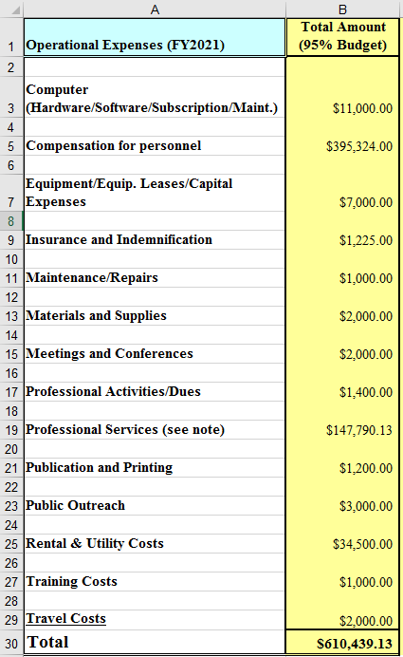

Note: Available FY19 Roll Over Funding will go towards Other Planning Studies in UPWP sub-category #21-08.05 to fund selected projects listed on the page 24 chart. The FY21 Budget consists of 80% Federal Funds and 20% Match Funds. Typically, the 20% match funds consist of 10% DelDOT and 10% Local MPO Partners contributions (some D/KC MPO partner cash contributions and “in-kind match hours”). However, DelDOT has opted to fund the Local D/KC MPO partners portion and will cover the entire 20% matching fund for FY21. Although the D/KC MPO is receiving 100% cash contributions for FY21, the operational costs will still not to exceed 95% of the total FY21 Budget ($642,567.50).

