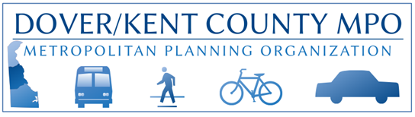
POB 383 / Dover, DE 19903 / http://www.doverkentmpo.org / 302.387.6030 FAX: 302.387.6032

Request for Proposal - Study Scope

Dover Kent County Metropolitan Planning Organization (MPO) is seeking priced proposals from qualified professional consulting firms to perform specific assignments in support of the MPO’s FY26 UPWP plan of work that will result in the implementation of a transportation, land use, and economic development strategy for Kent County, Delaware. Deadline for responses is 4:00 PM, February 27, 2025.

Project: Airport Road Corridor Improvement Study (Milford)

Narrative: This project was requested by the City of Milford. The study is meant to examine the evolving transportation needs of Airport Road between DE 15 (Canterbury Road) and US 113. It should recommend improvements for each of the intersections on the corridor and consider ways to enhance bicycle and pedestrian connectivity. Recommendations should tie in with other existing and proposed improvements to Airport Road and the surrounding area.

Expected Components:
Task 1- Project Start-Up
Task 2- Data Collection
Task 3- Community Engagement & Education
- Including an outreach plan for reaching the greatest number of nearby residents
- MPO’s Public Participation Plan is available here
Task 4- Key Issues Identification; including
- Alternatives Review
- Recommended Purpose and Need Statement
- Proposed Performance Measures
- Adherence to the Safe System Approach
- Identify any Equity/Title VI concerns (the MPO’s Title VI Plan is available here)
Task 5- Draft Document, including appropriate stakeholder presentations
- Sponsor (City of Milford)
- MPO Public Advisory Committee
- MPO Technical Advisory Committee
- MPO Council
Task 6- Final Document
- Electronic copy in Word format and PDF
- Relevant data and GIS shapefiles

Please provide the MPO with an estimated cost and an estimate of time needed to complete the outlined tasks.

