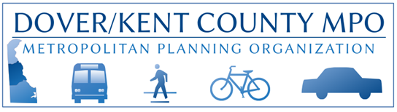
POB 383 / Dover, DE 19903 / http://www.doverkentmpo.org / 302.387.6030 FAX: 302.387.6032

Request for Proposal - Study Scope

Dover Kent County Metropolitan Planning Organization (MPO) is seeking priced proposals from qualified professional consulting firms to perform specific assignments in support of the MPO’s FY26 UPWP plan of work that will result in the implementation of a transportation, land use, and economic development strategy for Kent County, Delaware. Deadline for responses is 4:00 PM, February 27, 2025.

Project: Wheatley’s Pond Road/Underwoods Corner Road Intersection Safety Study (Clayton)

Narrative: This project was requested by the Town of Clayton. The study is meant to address the growing transportation concerns at the intersection of Wheatley’s Pond Road and Underwoods Corner Road, which include an increasing volume of vehicle and pedestrian traffic, congestion issues, and frequent vehicle crashes. The outcome of the study should include solutions for making the area more walkable, more bikeable, and safer for all modes of transportation. Recommendations should tie in with other existing and proposed improvements to Wheatley’s Pond Road.

Expected Components:
Task 1- Project Start-Up
Task 2- Data Collection
Task 3- Community Engagement & Education
- Including an outreach plan for reaching the greatest number of nearby residents
- MPO’s Public Participation Plan is available here
Task 4- Key Issues Identification; including
- Alternatives Review
- Recommended Purpose and Need Statement
- Proposed Performance Measures
- Adherence to the Safe System Approach
- Identify any Equity/Title VI concerns (the MPO’s Title VI Plan is available here)
Task 5- Draft Document, including appropriate stakeholder presentations
- Sponsor (Town of Clayton)
- MPO Public Advisory Committee
- MPO Technical Advisory Committee
- MPO Council
Task 6- Final Document
- Electronic copy in Word format and PDF
- Relevant data and GIS shapefiles

Please provide the MPO with an estimated cost and an estimate of time needed to complete the outlined tasks.

